Cranford Historic Preservation Advisory Board
38 Springfield Avenue
Cranford, NJ 07016
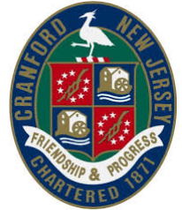
Cranford Historic Preservation Advisory Board
8 Springfield Avenue
Cranford, NJ 07016

HISTORIC RESOURCES PLAQUE ORDER FORM
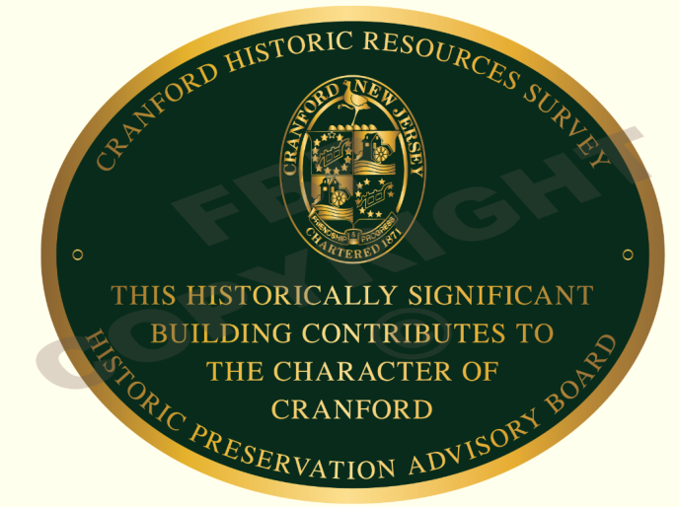

I would like to purchase an 8’ X 10” oval brass plaque that can be attached to my building in recognition of its contribution to the historic character of the North Cranford Historic District of Cranford.

NAME _____________________________________________________________________

ADDRESS __________________________________________________________________

EMAIL _____________________________________________________________________

PHONE ____________________________________________________________________

Please send this form along with a check payable to Cranford Historic Preservation Advisory Board (HPAB) to: HPAB, 8 Springfield Ave, Cranford, NJ 07016
$125 before August 30, 2020
$150 after September 1, 2020

In addition to your plaque you will receive a copy of HPAB’s DVD entitled “Cranford’s History and Architecture – A Journey Through Time” – a $15 value

Purchasing a plaque will not prevent you from making any changes to your property, nor does it require you to restore your property. Any modifications are governed by the Zoning regulations that cover all buildings in Cranford.

Plaques will be personally delivered to you

Visit our website at www.preservecranford.com or email us at preservecranford@yahoo.com

